# GABRIEL USER INTERFACE CHANGES

## V 1.12.5.0

### Exclude from Auto-Message

When adding a visit to a job, the user is able to exclude the customer from receiving a text message by removing them from the Auto-message.

A check box will be shown in the visit tab and be unique to each visit,

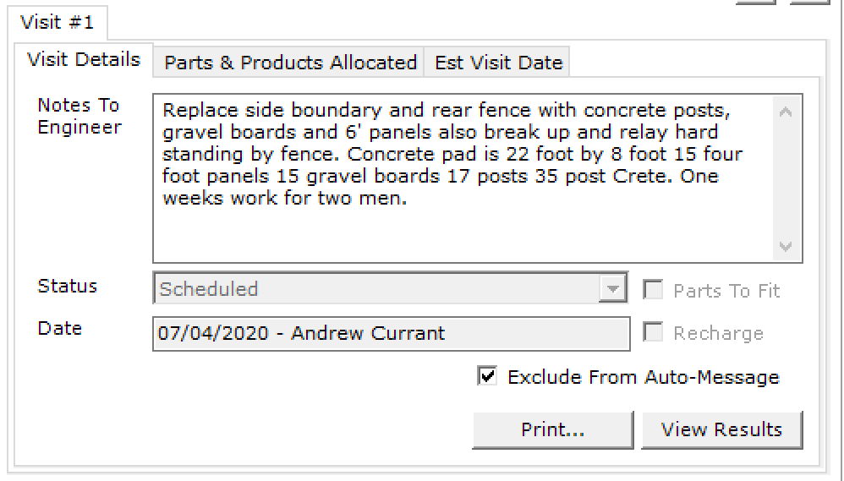

Once the job has been scheduled the user can right click the visit and include or exclude from the auto message section, the option will change depending on the status.

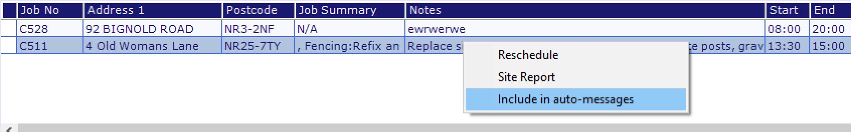

### Price list display

In setup you can now see the pricelist for jobs and change the prices from Gabriel without needing to submit a ticket.

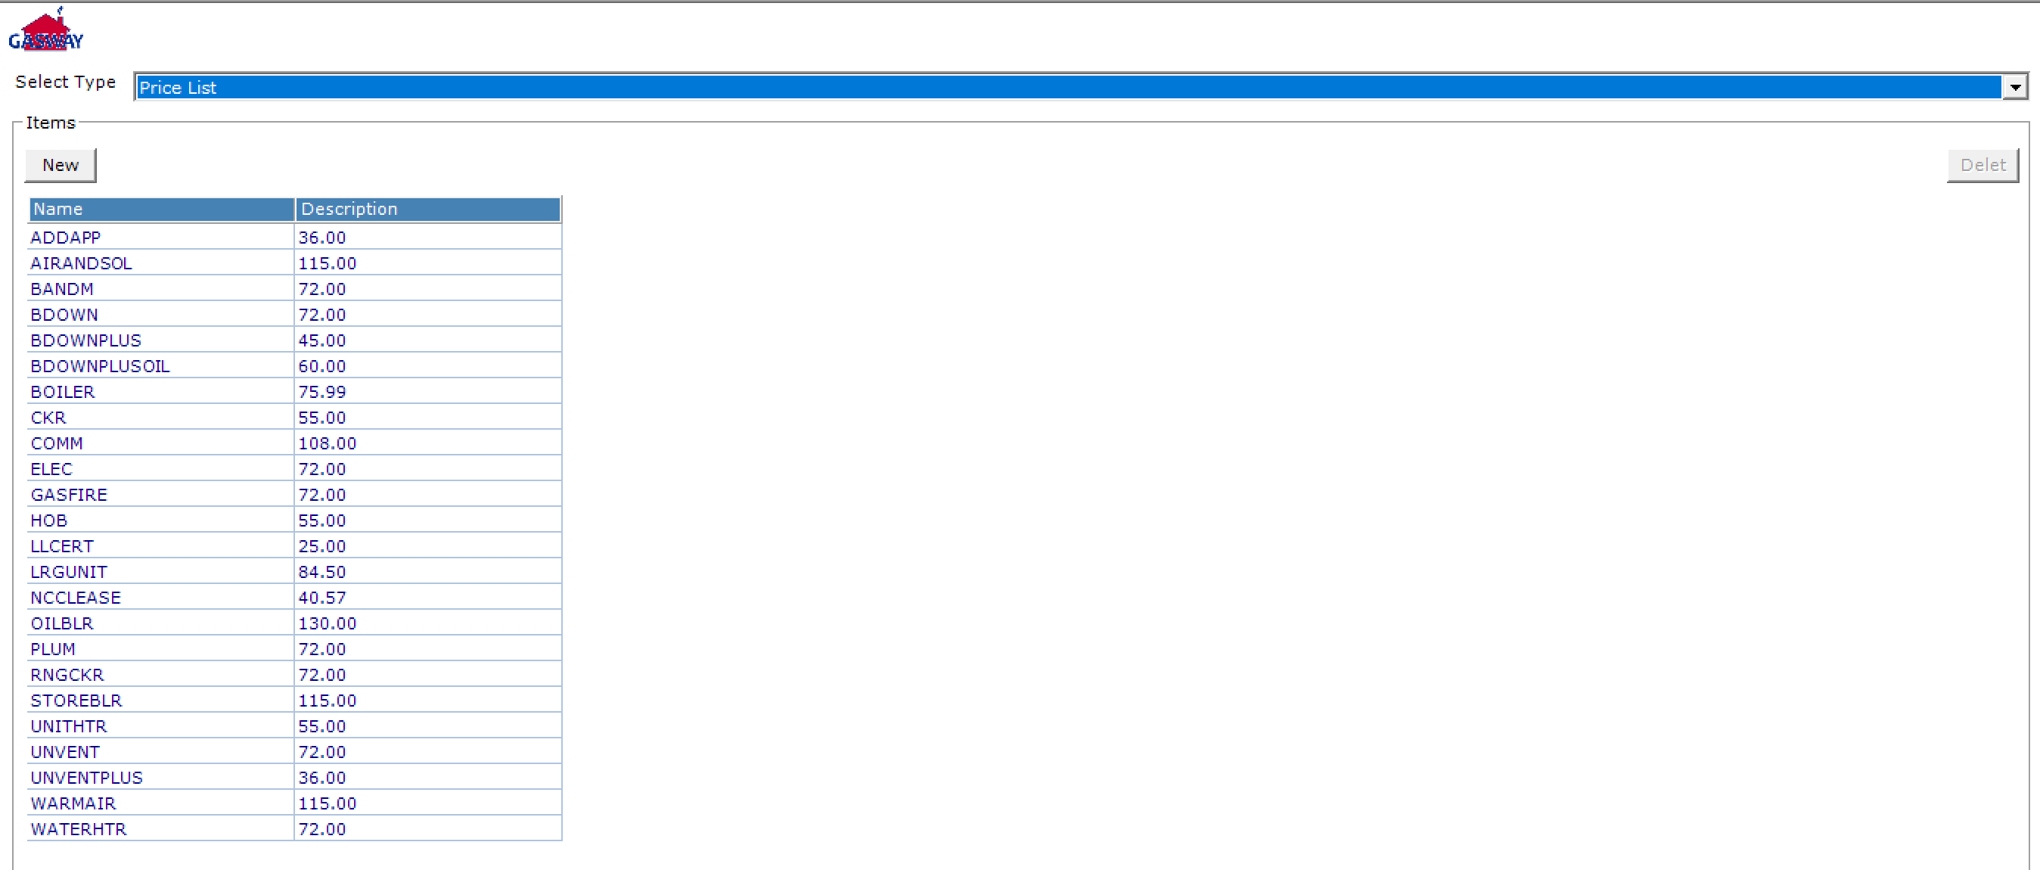

### Holding area

It will show you everything, but on the initial load it will only show one-month worth of updated visits.

When the holding area is loaded, it will by default display one-month worth of updated visits, to show all visits ticking the new checkbox and hitting refresh will show all visits open.

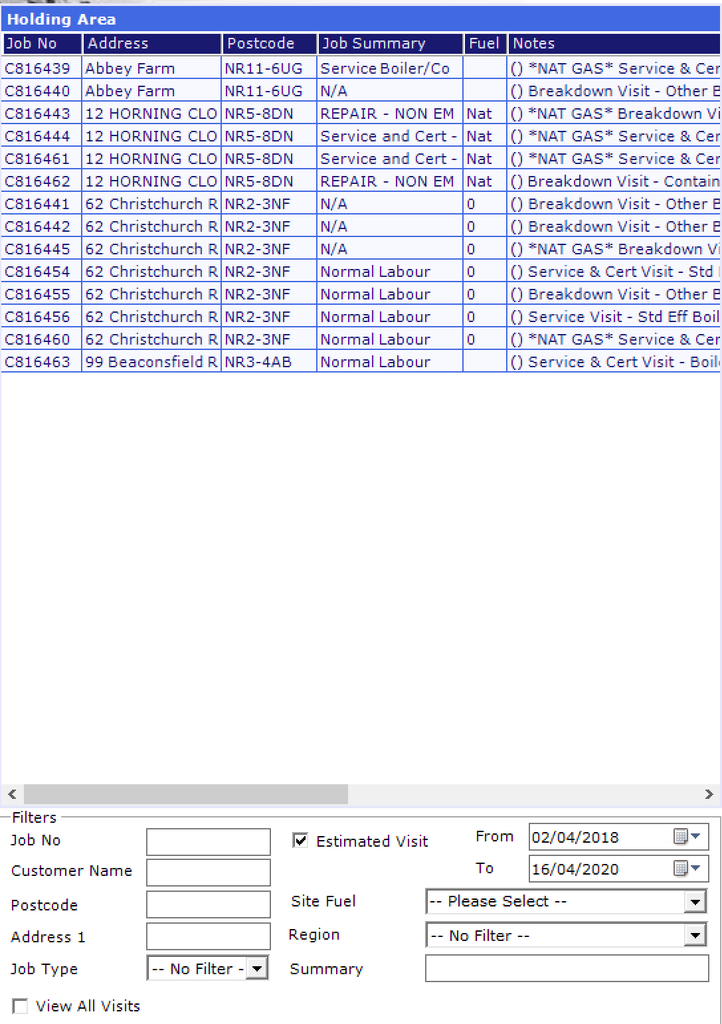

### Accommodation type

Sites now shows the accommodation type in a dropdown box, this can be changed to the correct option, this takes looking for the accommodation out of the site notes and into an easy viewable area.

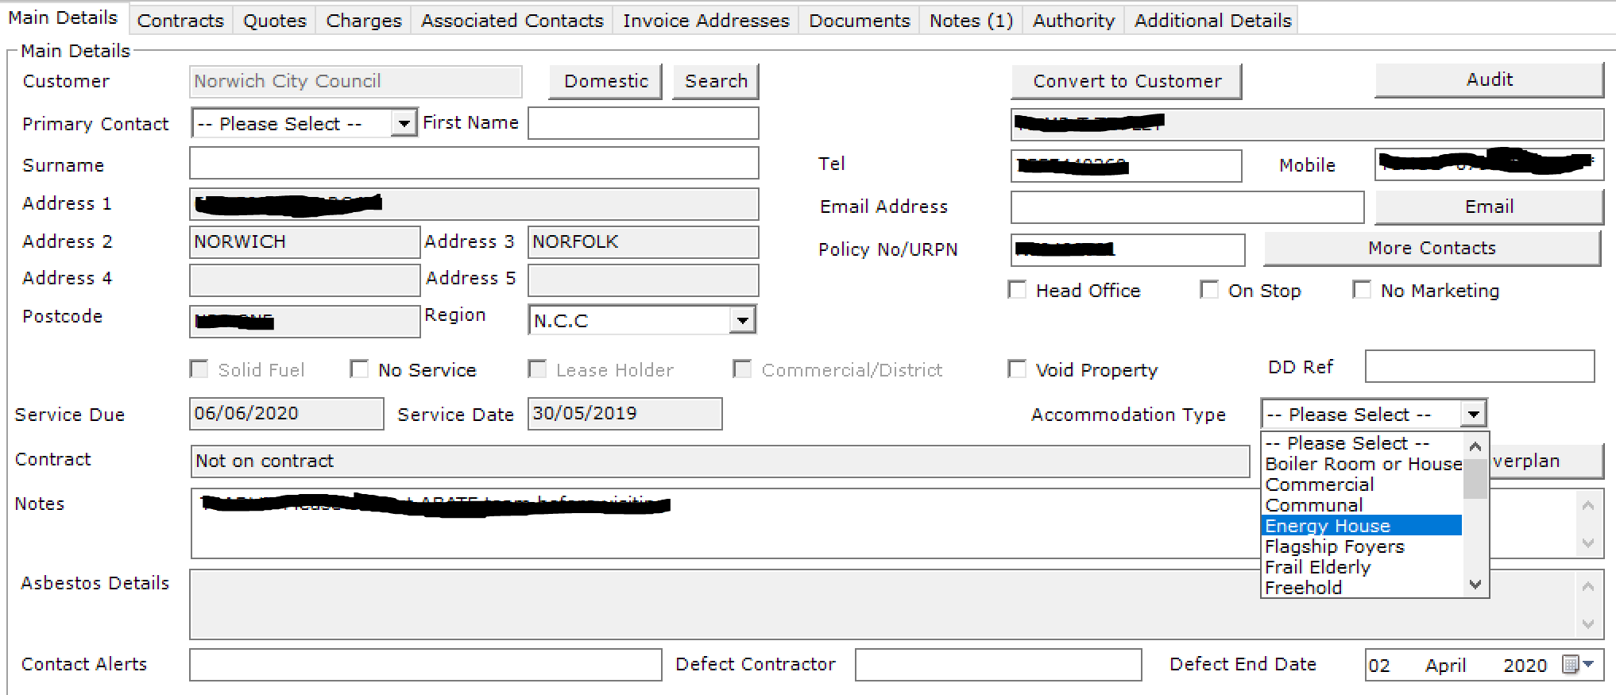

Due to the accommodation type being placed on the site page, ‘Reason for Contact’, ’Source’ and ‘Letter Report’ have been moved to ‘Addition Details’

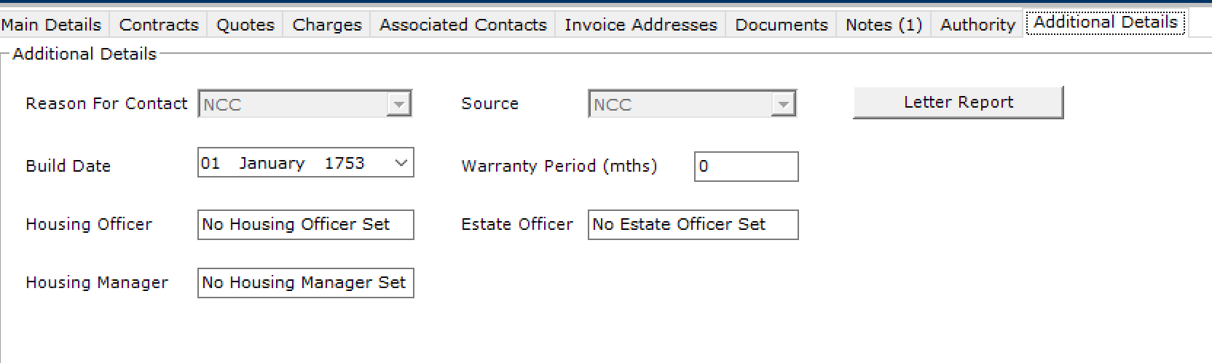

### Site Office button

When choosing a site for the customer, a new checkbox is displayed, this will filter down the results to only show sites that are marked as ‘Office’ as an accommodation type.

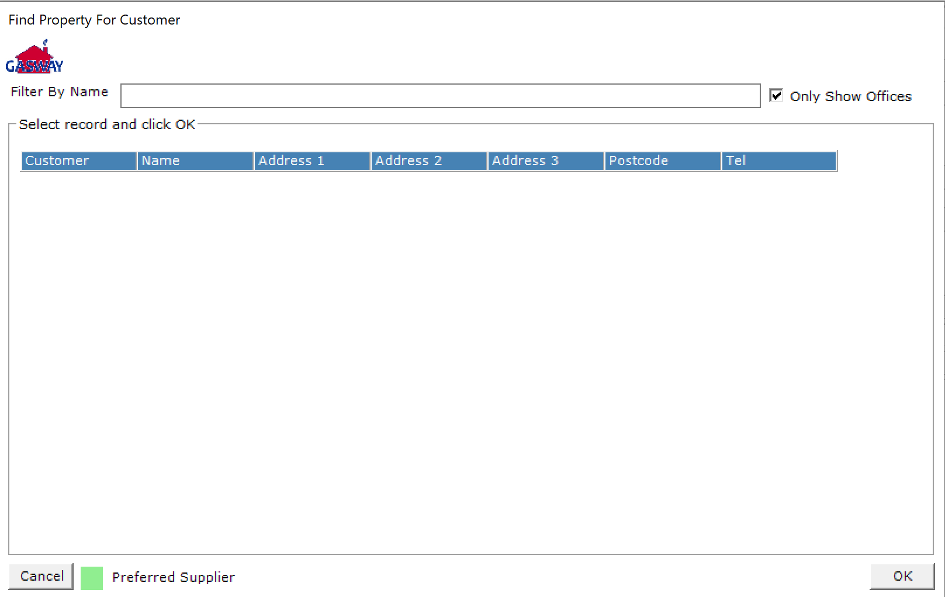

## V 1.12.3.0

### Stock take reason - RFT

A new column has been added to stocktake when adjusting the values, when any adjustments are made an reason must be added from the dropdown options.

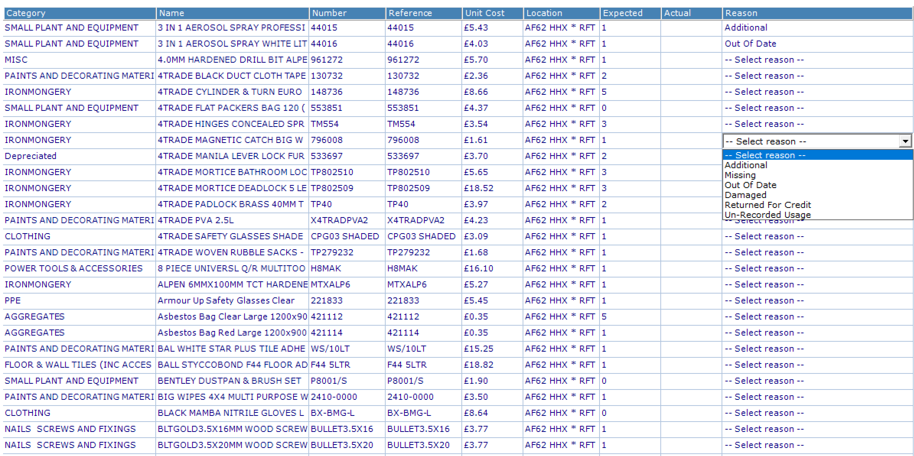

### Region value in Job manager

A new search filter has been added to job manager, this will search a specific region, and return the results in the grid below.

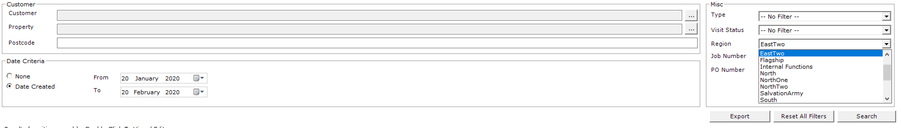

### Recurring Absences

Inside the scheduler when added an absences, a new tab called ‘Recurring’ has been added, you select which engineer/user you wish to book holiday off for, then the dates between, and what days of the week the user will be off.

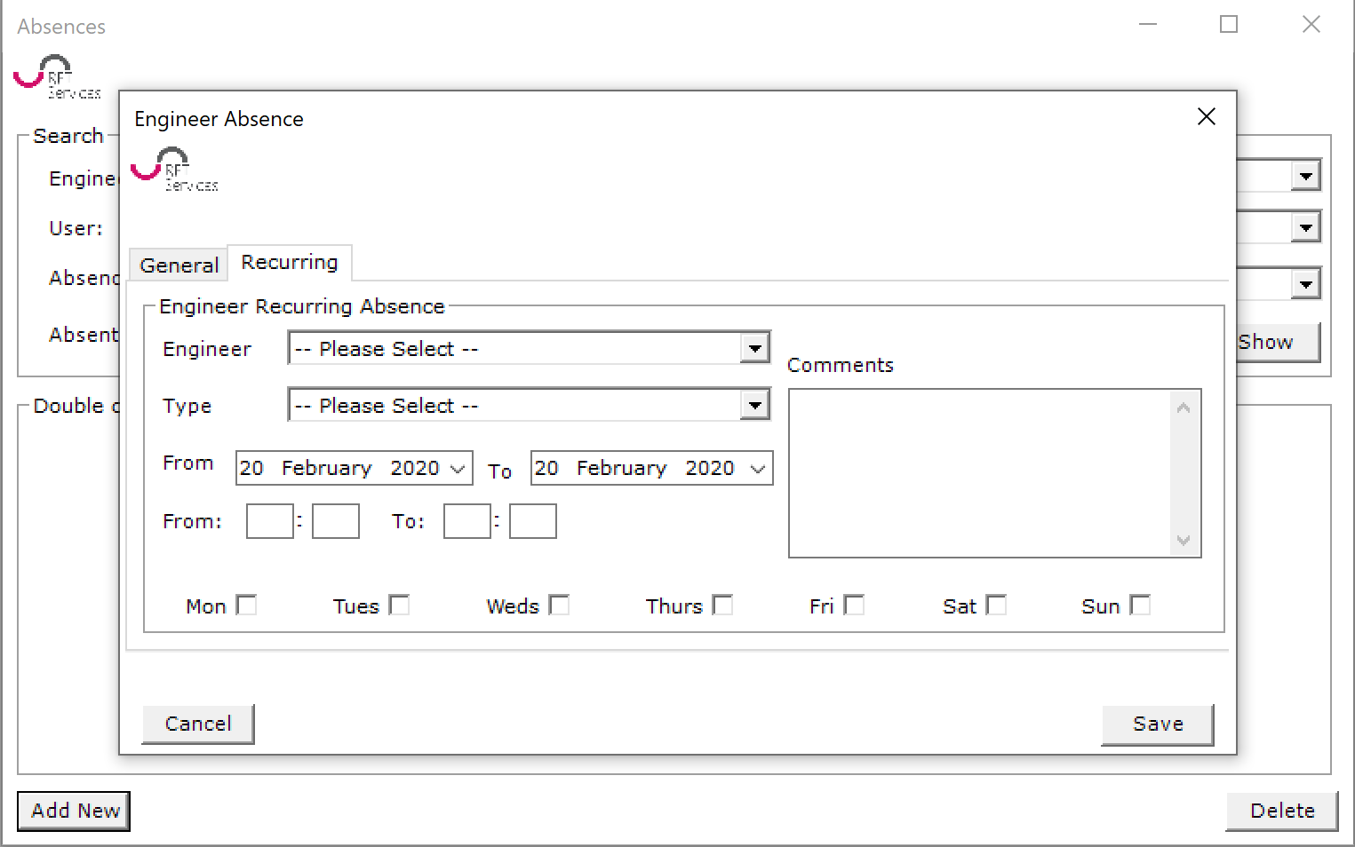

For example, if the if a user is having every Monday and Tuesday off for the next month, it will only put them in for these days/Times, leaving the rest of the week alone.

### Parts and products allocated changes

Removed buttons to add parts and products, the space will now only show a button if an ‘Auth Code’ is required

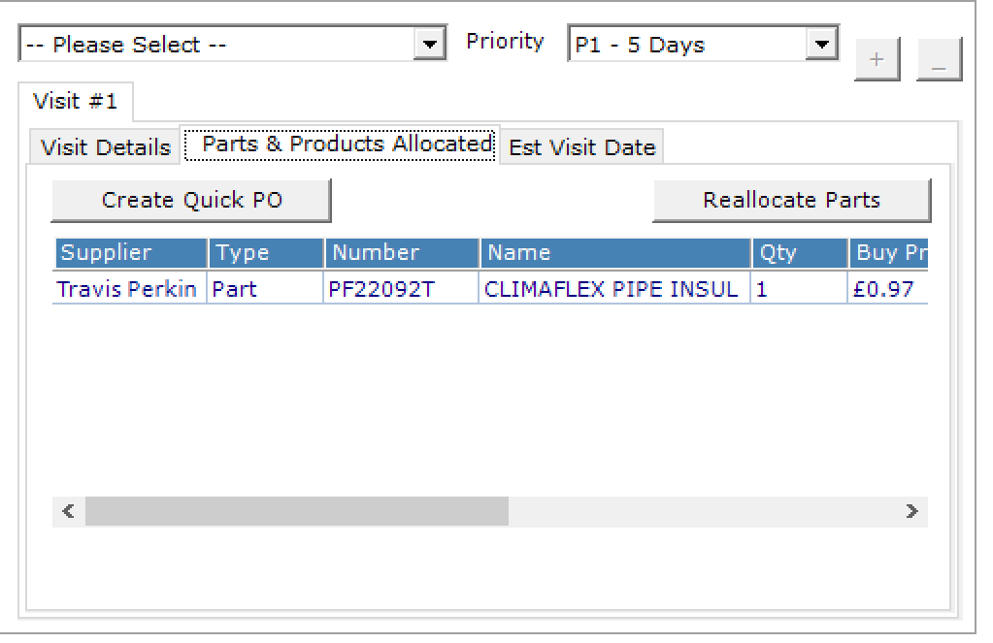

### Parts and products changes in results

Removed section at the bottom ‘Parts and products needed’

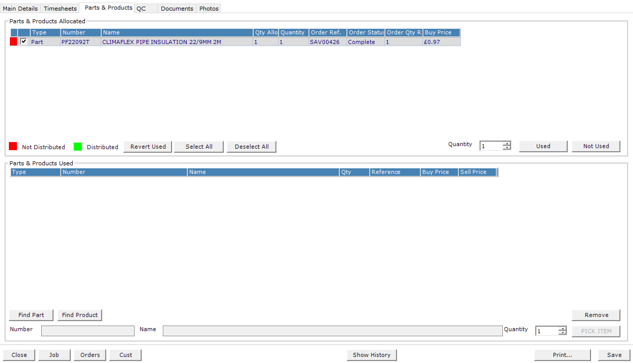

## V 1.12.0.0

### Solid fuel worksheet

A new worksheet for solid fuels has been added, also all the other fuel types have had the UI elements cleaned up and aligned, no more empty open space, making it cleaner and easier to use

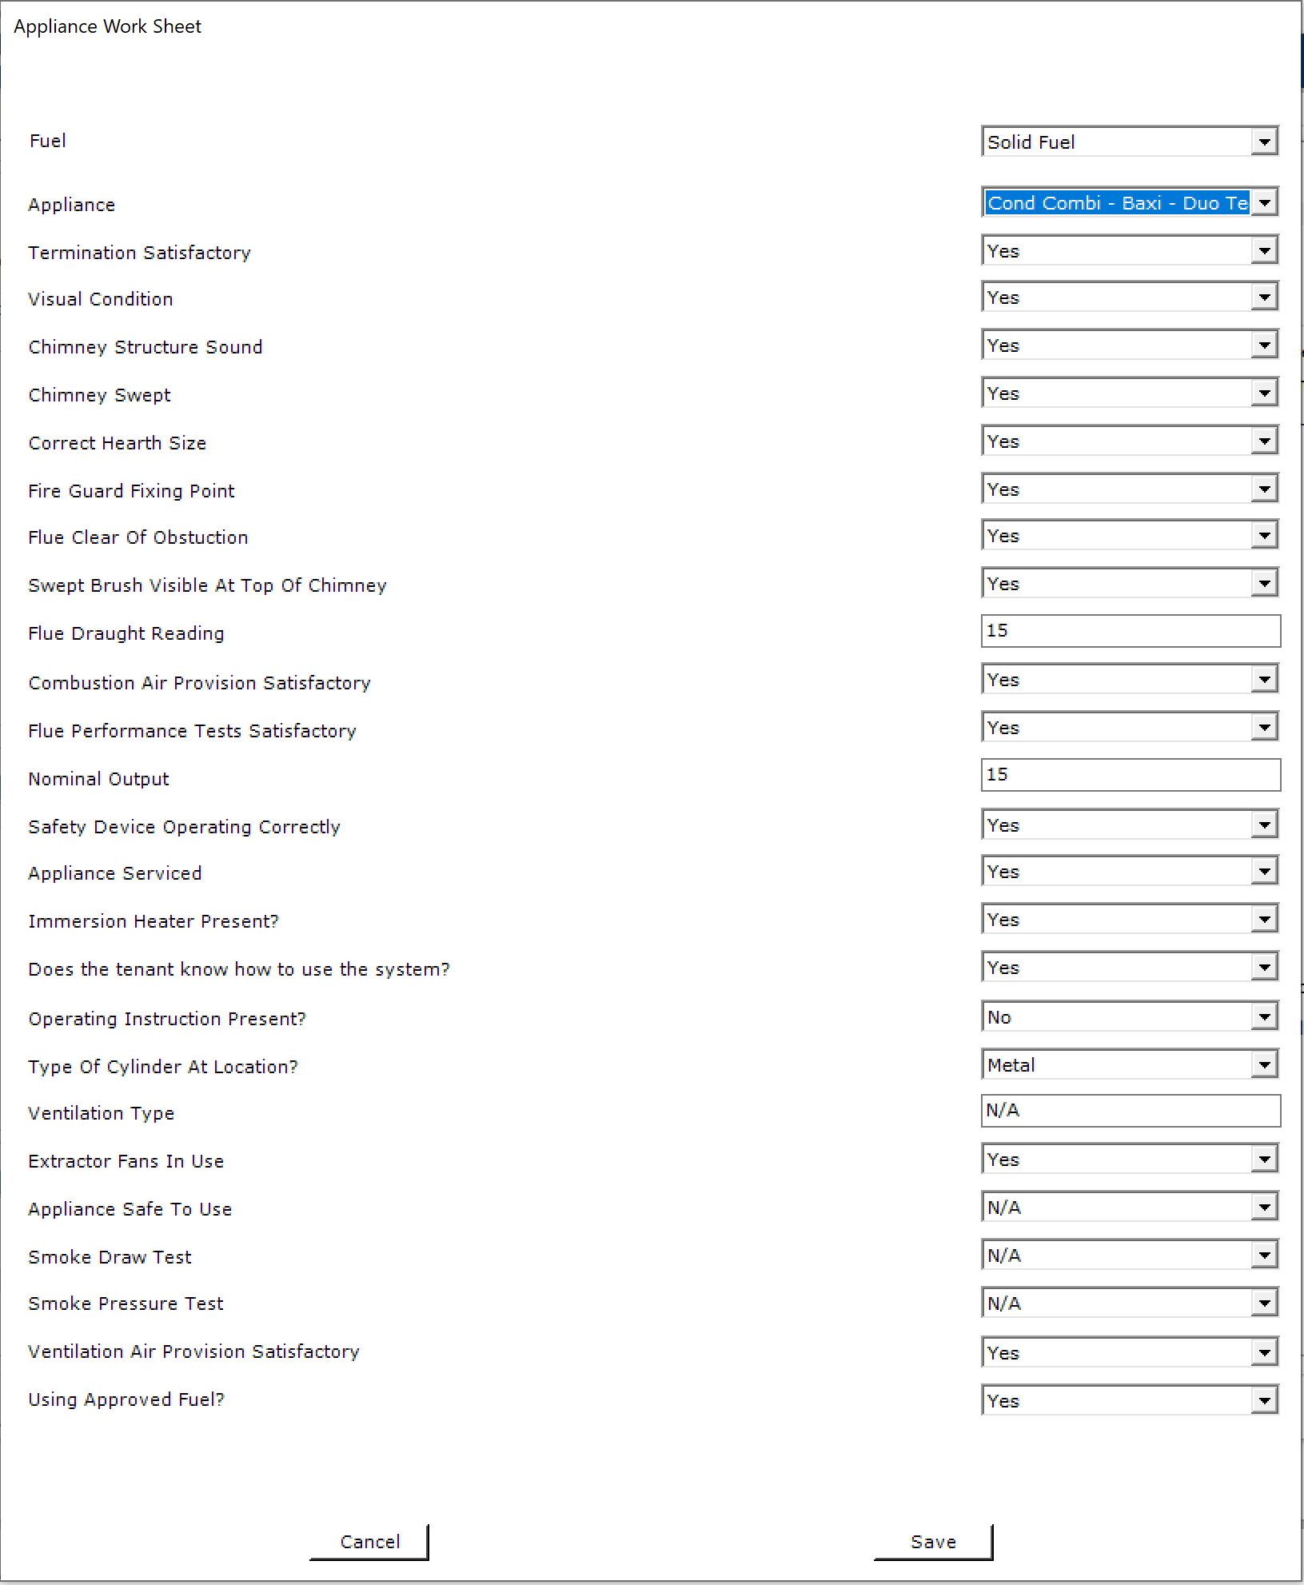

### Defect contractor / end date

Added two new boxes on the bottom right of Site screen, this shows the defect contactor and the defect end date. If the defect contractor is filled it will show as a yellow.

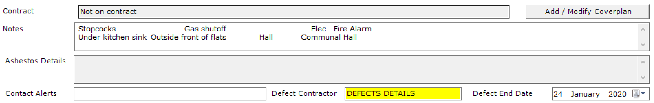

### Stock profile navigation

Van stock has now been renamed to ‘Stock profile’ the UI has been changed on all pages to reflect this.

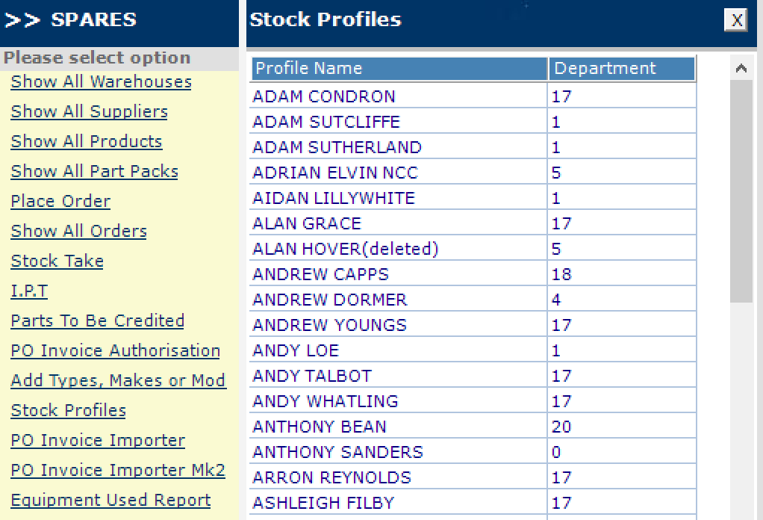

### Stock Profile

Removed vehicle information such as insurance and MOT dates, and replaced with the current engineer attached to the stock profile, and the fleet van they have assigned to them.

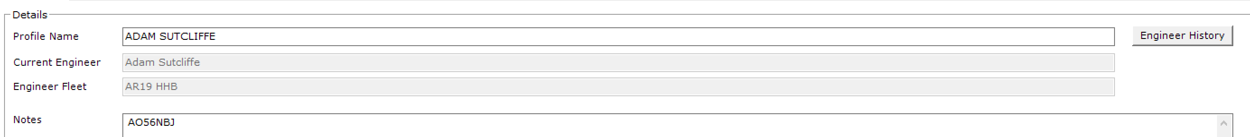

### Quick PO

Added a date box to allow user to change the date for when the order is placed. Works the same as when adding an order in ‘place order’

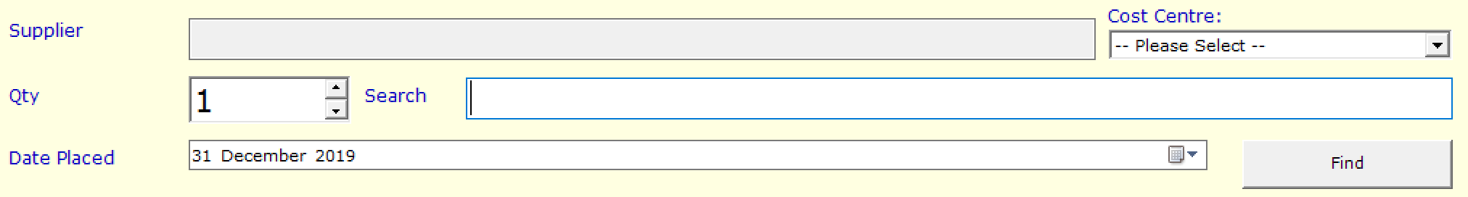

### Display engineer (Scheduler)

Created multiple filters to help search and narrow down engineers to choose, this includes region, postcode and name, as you type this will dynamically narrow down the results,

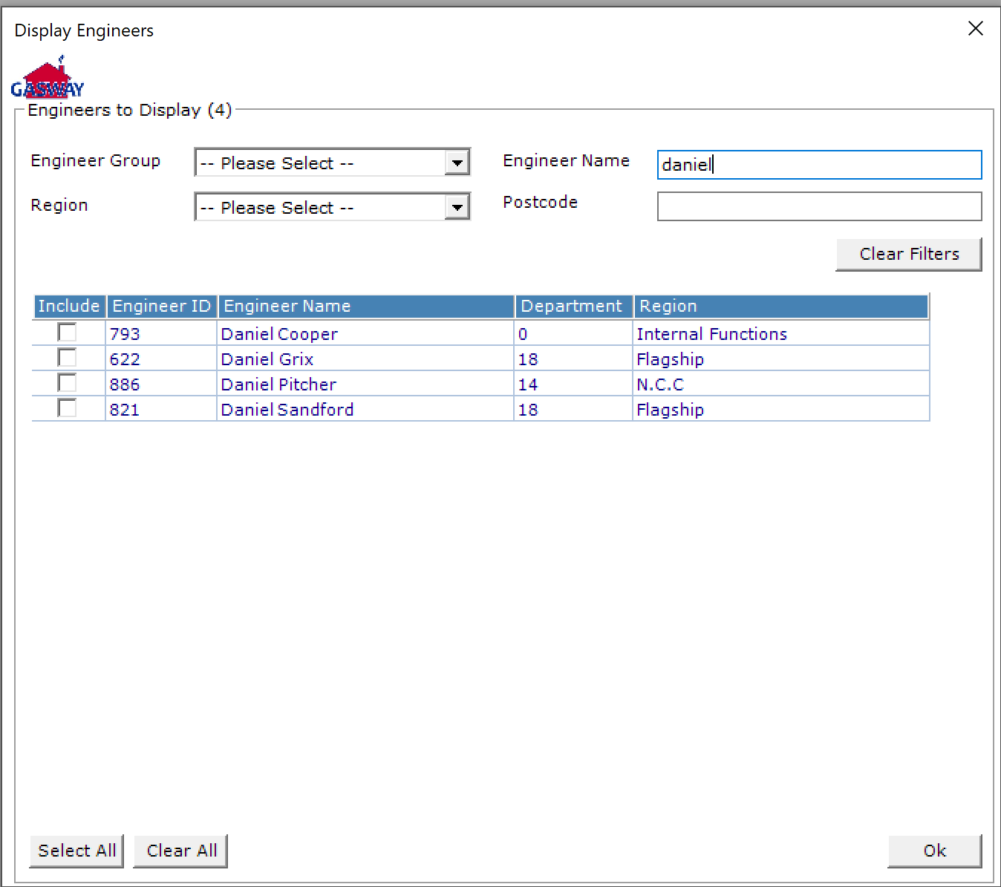

Select all button will only select all that are currently visible.

### Quick engineer view (Scheduler)

A new view has been created to give quick information about the engineer such as name, region, manager and what postcodes and qualifications they have attached to them, this can be viewed by double clicking the engineer from the list.

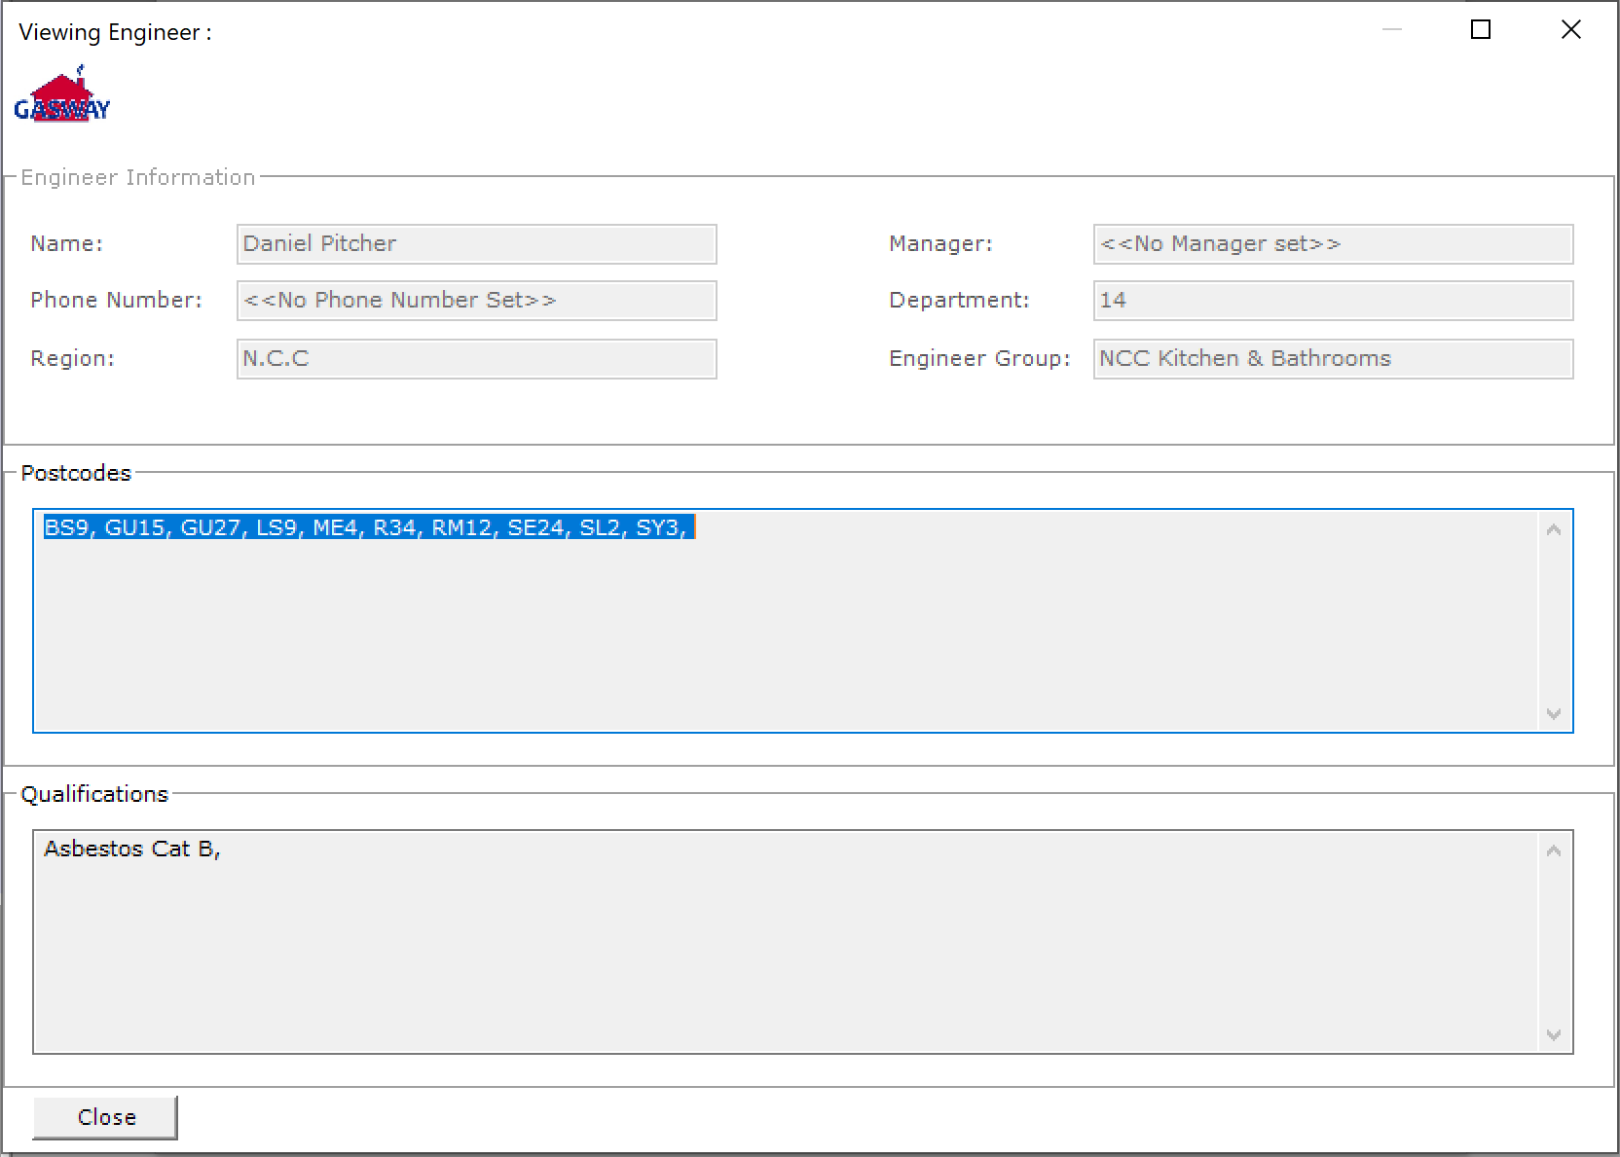

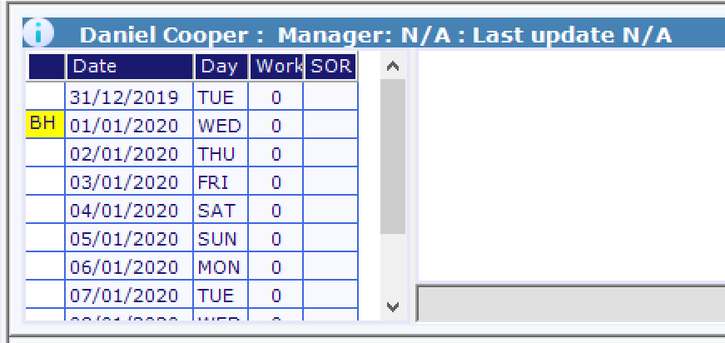

It can also be displayed by clicking the Information button when the engineer is being displayed in the scheduler.

### Stock take

Removed Shelf and bin filters, added a stock valuation amount in top right hand corner, this will display the current valuation of any stock currently being shown, this will update as the filters are being inputted.



## V 1.10.0.0

### Part Packs

The suppliers that can fully provide a pack, is now visible at the bottom the window.

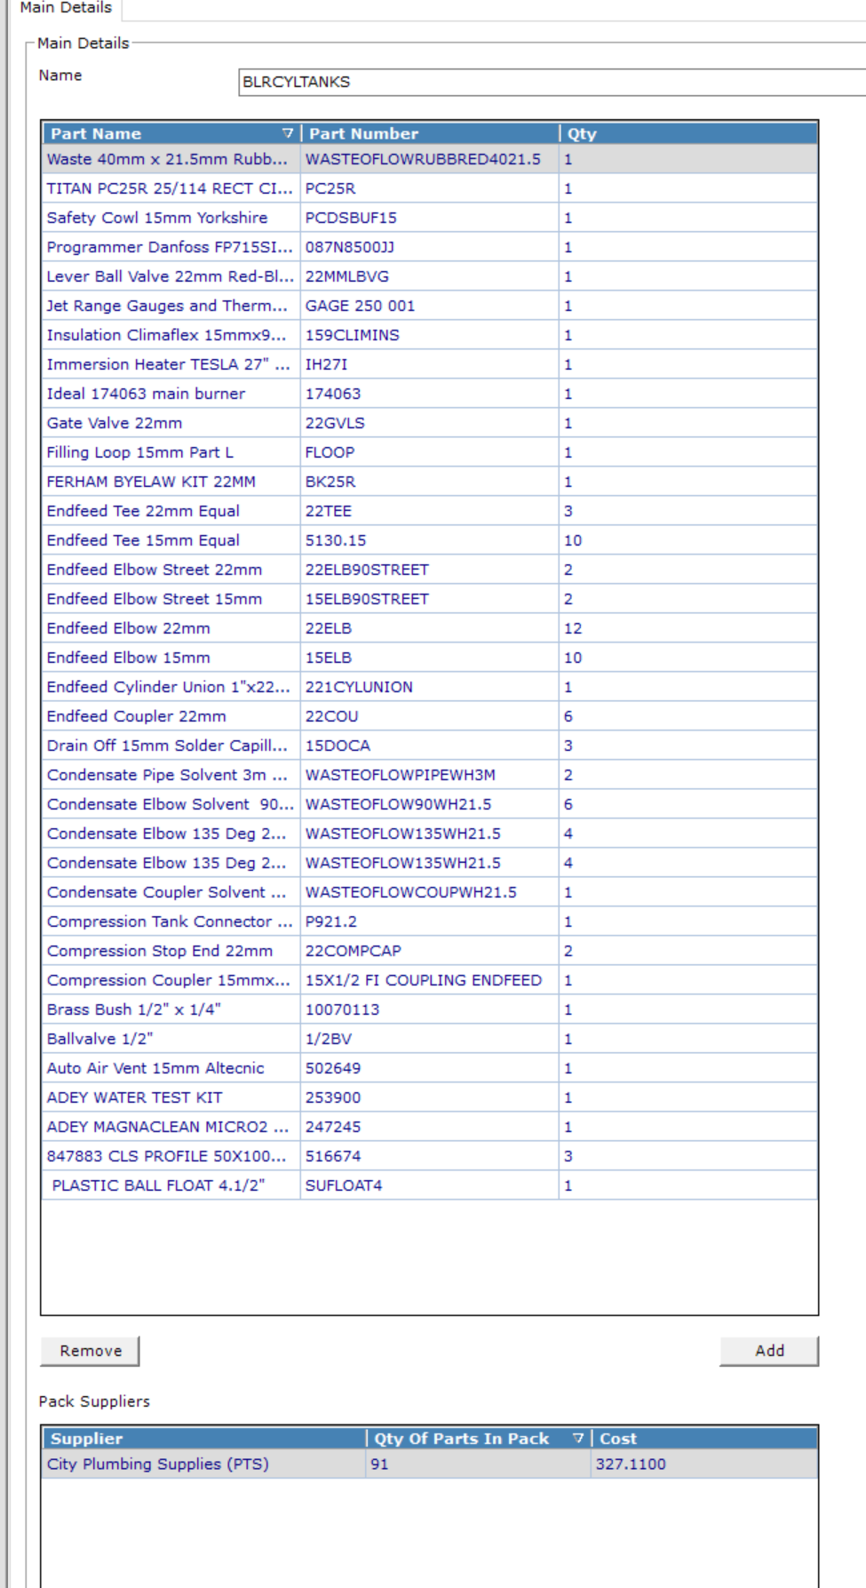

### Contact Attempts

On the front screen of a job, the last contact attempt made will be visible.

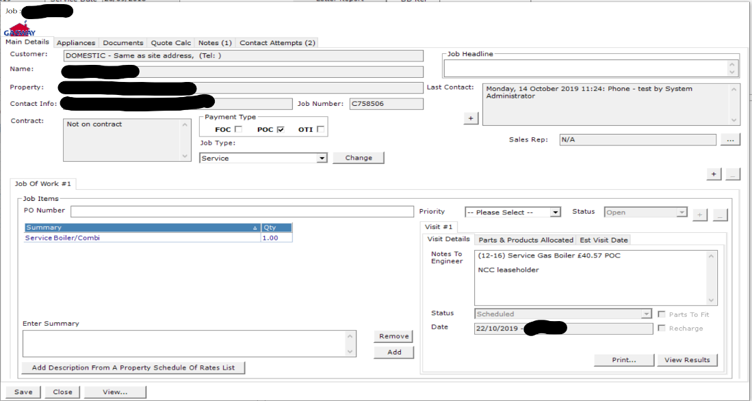

You can add a new attempt by clicking the + symbol next to the textbox. In the modal, you have the option to select the method, date and add additional notes about the attempt.

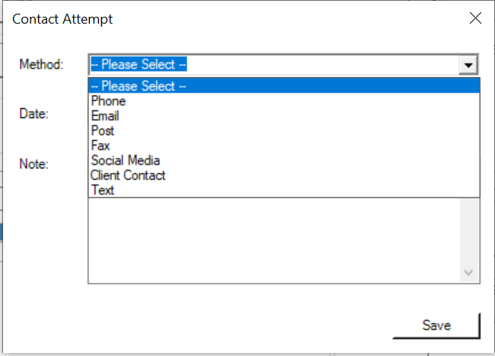

If you wish to see all the attempts made on the job, you can view it on the Contact Attempts tab.

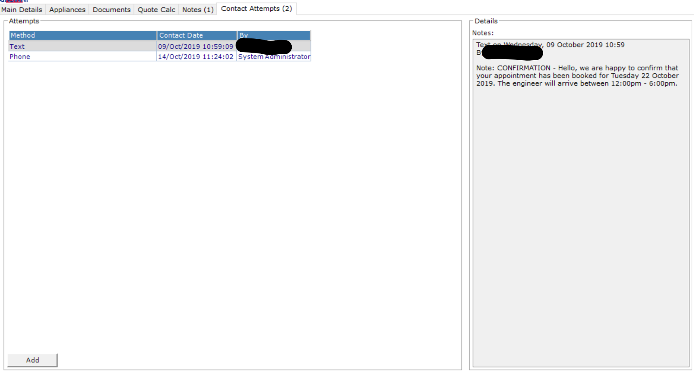

We suggest you use this area to distinguish the difference between a contact attempt and an note. As this information may be used for reporting information to clients/personnel.

## V 1.8.0.0

### Invoice Address

A new option to select a department has been added to invoice address selection

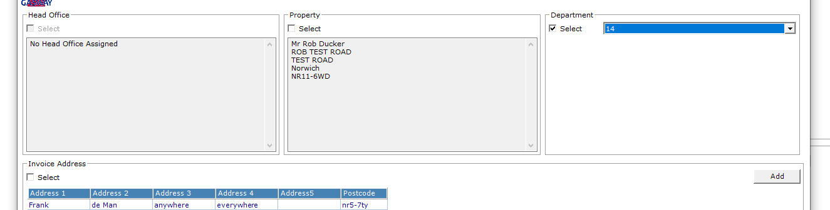

### Site Defects and Contact Alerts

The site window will now highlight if a site has defects and/or contact alerts



### Engineer Scheduler

The Engineer’s scheduler will now display the last timesheet the engineer logged for the day. This will give you a rough idea of their location.

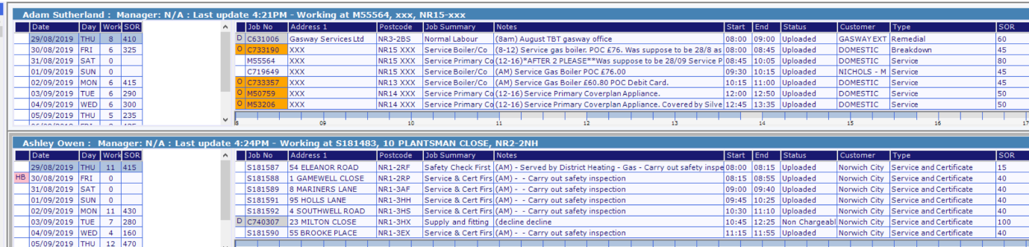

### Price Costing

On customer window a text box ‘**Job Spend Limit’** has been added to enable setting of job spend limit for each customer.

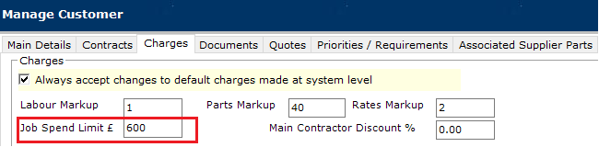

On engineer window a text box ‘**Visit Spend Limit**’ has been added to enable setting of visit spend limit for each engineer.



On customer SOR job types a text box ‘Job Spend Limit’ has been added to enable setting of job spend limit for each region and specific job types.

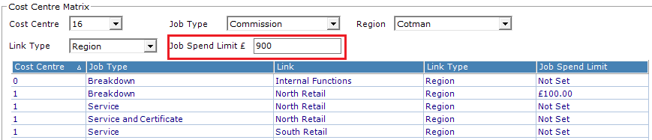

#### Quick Order Creation / Order Confirmation

Upon create/confirm, if order is not within spend limit

* and user has PO authorisation, following warning message will be displayed: "Job cost capacity was exceeded when creating this purchase order!". Order will be taken straight to complete status.
* and user has no PO authorisation, following warning message will be displayed: " "Job cost capacity was exceeded when creating this purchase order!

Please note that this order is currently awaiting approval". Order will be taken straight to awaiting approval status

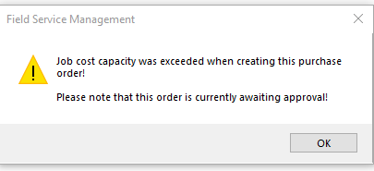

#### Authorisation Request

When a spend limit is hit by an engineer in the field he/she will see this:

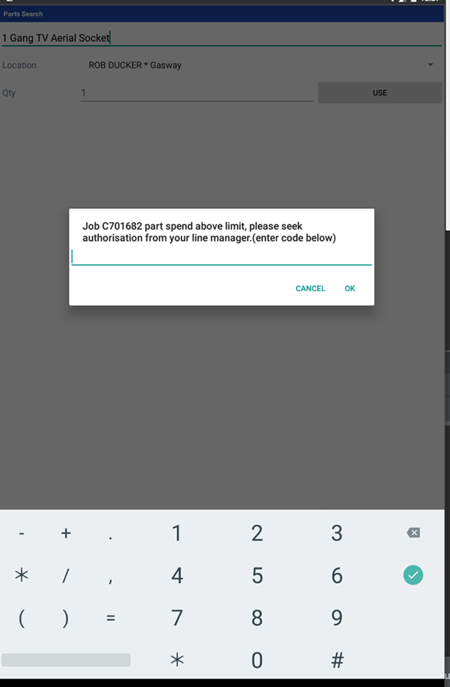

#### Order Authorisation

Upon receiving request to authorise order from engineer, go to ‘Parts & Products Allocated’ tab in the job window, then click ‘Auth Code’. An authorisation code/number will be generated. Send this number to engineer.

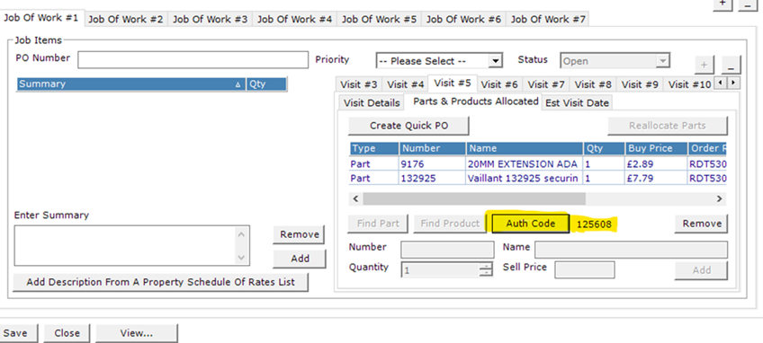

### Engineer – Roles

A new feature has been added to allow user to setup engineer roles and to assign role to engineers.

#### Setup Roles:

From main screen click ‘Setup’ menu item then select ‘Engineer Roles’.

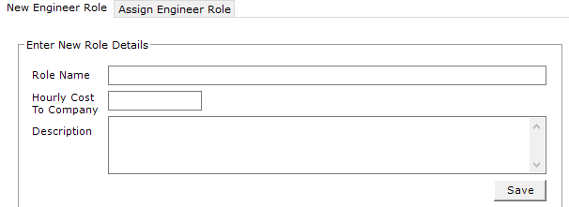

Enter details and then click ‘Save’

#### Assign Engineer Role:

On the same screen, click ‘Assign Engineer Role’ tab

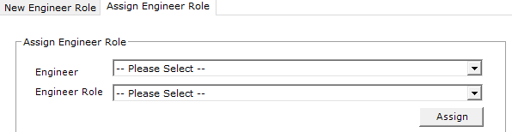

Select engineer and role and then click ‘Assign’

Assigning engineer roles can be done on ‘Engineer’ screen as well.



## V 1.7.0.0

### Customer - PFH

On the bottom right of the customer window a new check box ‘**Is PFH**’ has been added. This is to enable flexibility for customers to join the PFH scheme.

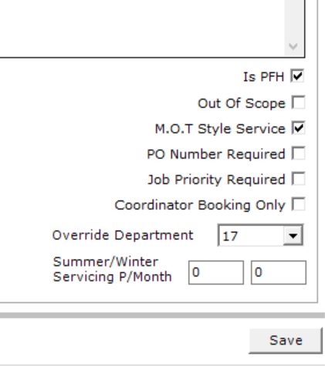

### Engineers – Link to User

A new dropdown list has been added to allow Engineers to be linked to their Gabriel user accounts. Once a link has been established, this will remove the user from the User Quals section of Gabriel.

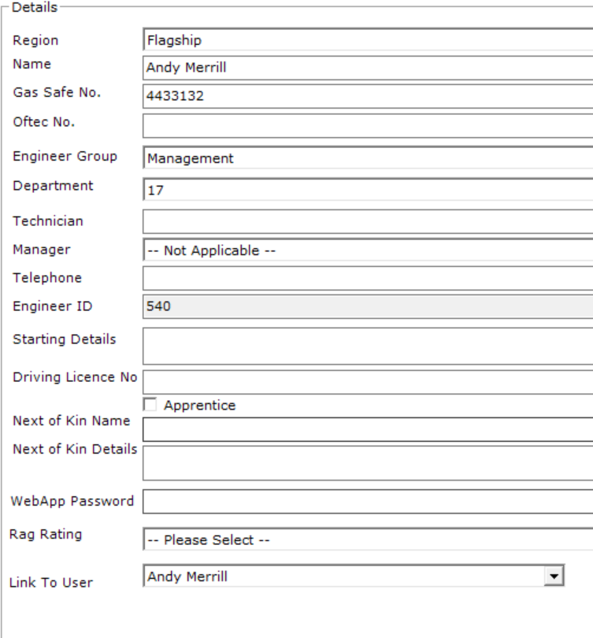

### Sites – Void Date

Once the void checkbox has been clicked, the user will be presented with a modal to select a date.

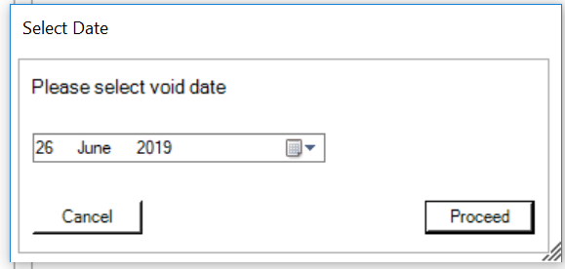

Once the user has selected the void date, a new label will be present with the void date.

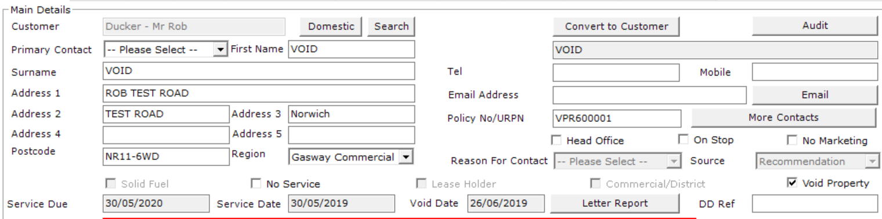

### Job – Headline

Within the job window, you can now add a short description/headline. This is to allow user to understand the initial reason for the job rather than trolling through the engineer notes.

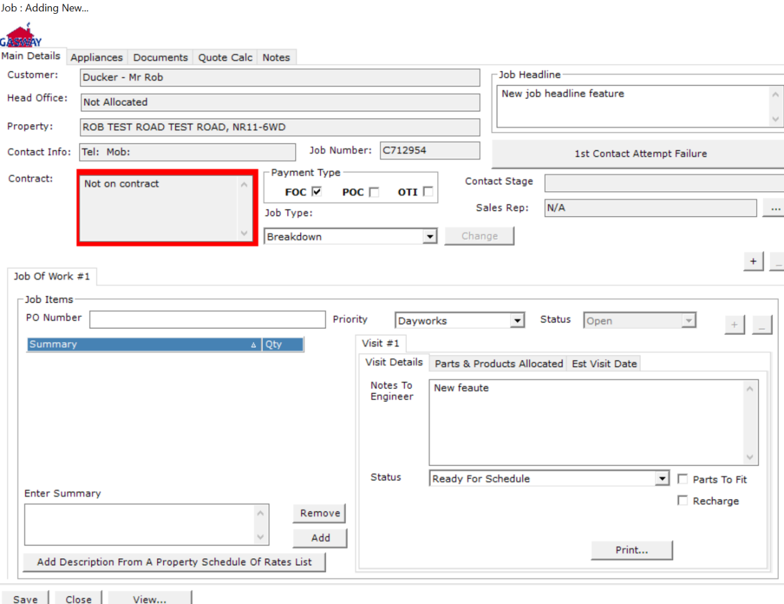

### Invoiced Manager – Regenerating Sales Credits

At the point of regenerating a sales credit, if the system can find more than one credit, it will prompt you to either merge all credits into one document or print the individual credit.

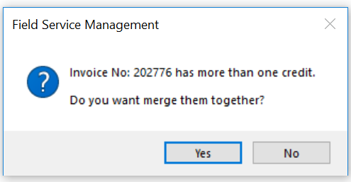

### Orders – Reallocating Orders to Jobs

Within the ‘Parts & Products Allocated’ tab in the visit window of a job, there is a button to reallocate parts. This feature originally moved parts from one visit to another within the same job.

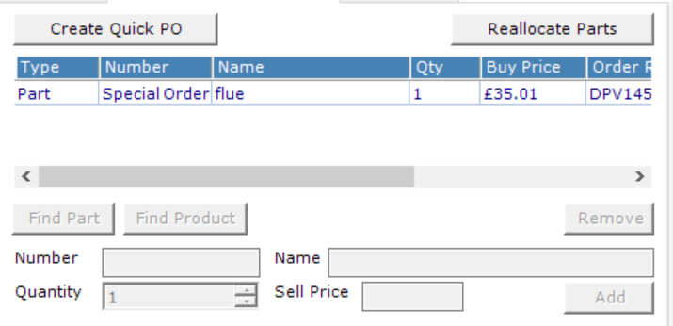

The feature has been improved, to allow job search. On initial load of the form, the job number field will be populated with the current job number and the drop-down list will be filled with current eligible visits within that job. If you want to move the part to a different job, click the change button.

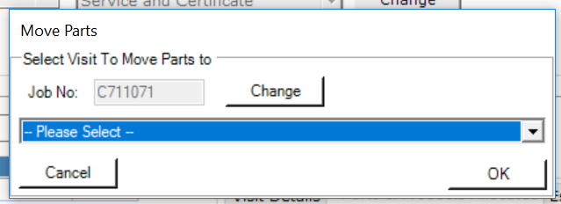

Once the button has been clicked, the drop-down list will be disable and the job number field will become editable.

Enter the job number you wish to move the parts to and click the search button.

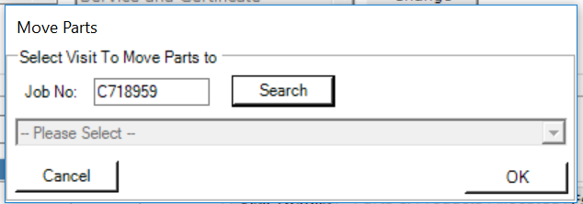

If eligible visits are found, it will populate the drop-down list. Select the visit you require and click.

Please note that parts that have been marked as used/return cannot be moved. Additionally, visit that any visit past the status of scheduled, will not be present in the list.

### Sales Credits – Generate Individual Credits

The ability to generate an Individual sales credit against an invoice that has multiple sales credits. If an invoice has multiple sales credits against it, you will be prompted to either print all credits merged or just the individual credit

